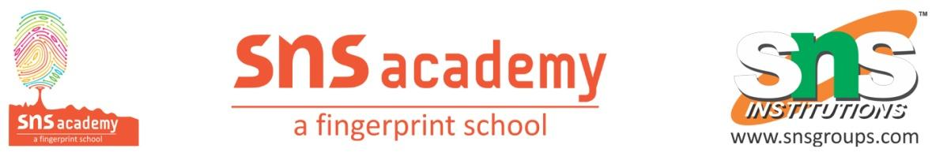
GRADE 8 WORKSHEET
MANUFACTURING INDUSTRIES
1.From where did the Silicon Valley get its name?
a.Got its name from the meaning of the word silicon.
b.Got its name from particular computer software.
c. Got its name from a valley by the same name that existed in California, US.
d.Got its name form the silicon that was used to make chips for computers
- Basket weaving, pottery and other handicrafts are all examples of
  - Small scale industries
  - Medium scale industries
  - Cottage industries
  - Large scale industries
- Name the major industry which provides the primary needs of humans like clothing.
  - Chemical industry
  - Transport industry
  - Textile industry
  - Iron and Steel industry
- What is the output of iron and steel industry?
  - All of these
  - Iron ore
  - Pig iron
  - Steel
- Which industries are also known as village or household industries?
  - Large Scale industries
  - Cottage industries
  - Small Scale industries
  - None of the above
- Match the following:
Column A | Column B
(i) Silicon Plateau | (a) Osaka
(ii) Manchester of India | (b) Deccan Plateau
(iii) Manchester of Japan | (c) Bhopal
(iv) Industrial disaster 3rd December 1984 | (d) Ahmedabad
  - The river that provides sufficient water to Osaka’s textile industry is……………..
  - The process of smelting is done in a…………
  - The four states where most steel producing centres are located are …………., ……………, …………. And………
  - The first cotton textile mill was established in Ahmedabad in……………
  - Silicon Valley is located near the ………………Mountains<
- State True of False:
  - Osaka is known as ‘Manchester of Japan’.
  - IT industry is called knowledge industry.
  - Coal mining industry is marine-based.
  - Forest based industries utilise forest produce as raw materials.
- Explain agro-based industries.
- Name the factors affecting location of industries.
- What are small scale industries?
- Describe the major industrial regions of the world. Mention any three industrial regions in India.
- What are the factors that helped Ahmedabad to become a textile centre?

